**CHAPTER ONE**

**1.0 Introduction**

The global reach of online auction market places allows for the buyers and sellers to overcome geographical constraints and purchase products anytime from anywhere over the internet. The online auction market provides the consumers with great advantages of low prices, greater product selection and greater efficiency compared to the usual traditional offline markets (Ghose et al, 2006). The use of online auction system makes use of the decision making assistance tool that results in greater buyer’s certainty towards their choice of the seller’s and product that they make. The decision making assistance tool consists of three parts that is the product information signals, seller’s rating scores and seller’s shilling activities.

The product information signals seek to fully describe the product through the use of textual and visuals, the use of third party product certifications, description of the product characteristics, the product usage and book value. This strives to ensure the buyer’s product certainty. The decision making assistance tool also provides for seller’s ratings by making use of the feedback scores. These feedbacks are given by previous winning bidders and they evaluate the online auction product sellers. These bidders give detailed seller ratings of all aspects of the seller and giving scores for example giving scores of how accurate was the items description, how satisfied they were with the seller’s communication and how quickly were the products transported to them by the seller.

The other important aspect of the decision making tool involves the process of coming up with seller’s shill ratings. Shilling is the act of introducing fake bids into an auction on the behalf of the seller to artificially inflate the price of an item (Weinberg, 2003). To come up with shill rating the system monitors the shill activity characteristics which include those bidders who make a lot of repeated failed bids on the same seller. Shills usually have higher number of failed bids per seller ratio. The auction house maintains records of the number of bids a bidder has placed for every seller that the bidder has interacted with. This information is used to come up with a shill score. Detailed evaluation of the product and seller and the use of the decision making assistance tool ensure consumer’s certainty on the choice of the sellers and the products that they make.

**1.1 Background**

A few decades down the line, auctions were carried in auction houses and the bids were made with the auctioneer delegating the bids and this method required the physical presence of the bidders, thus it resulted in a number of limitations. This led to the use of online auctioning which allow for the auctions to be carried out over the internet from anywhere in the world. The advent of online auctions presents on its own, different downsides due to the lack of proper evaluation techniques of the products and the sellers. The current systems do not allow for proper description the of the kind of sellers and the kind of products that they sell. These systems do not provide enough detailed information to evaluate the type of sellers and their products. This result in the buyers uncertainty thus resulting in the reduced effectiveness of the online auctions making people opt for offline auction markets. Most available current auction systems do not fully provide product descriptions as well as fully evaluate the different type of sellers that participate in the auctioning process. Online systems come from a background where there is no full evaluation of the shilling activities that take place in different auction systems. The evaluation of shilling activities goes a long way in providing for certainty in the different type of seller. This can be achieved through the provision of the shill scores or shill ratings for each seller in an auction system. By providing the sellers shill rating the different bidders can easily make choices for the different sellers they decide to bid for their products.

**1.2 Problem Statement**

The problem that usually arises in online auction is that of the buyer’s uncertainty towards the sellers and their products due to the lack of physical evaluation of the products (Pavlou, 2008). The problem of product and the seller’s uncertainty negatively affects the key success of the outcomes of the online auctions. The implementation of an online auction system that provides detailed seller and product descriptions results in the increased certainty of the bidders towards the choice of the products and sellers that they make. There is also the problem of getting a different product delivered to buyers, different from what he/she paid for, with either low quality, less physical attraction or below buyer’s taste and standard.

**1.4 Aim**

To design and implement an online auction system for sellers and buyers to efficiently carry out transaction with minimal stress with little or no human intervention.

**1.5 OBJECTIVES**

1. To allow registration of the various sellers and the buyers of products (bidders)
2. To enable sellers upload products for auction with appropriate description of products.
3. To enable seller set time limit for each product being auctioned.
4. To notify the buyers (bidders) of new bids made in the bids that they participate in.
5. To generate reports for each completed bid in the auction system
6. To compute the seller’s ratings using the feedback scores from the bid winners

**1.6 Justification**

The use of online auction systems that do not allow for full effective product description and failure to provide decision making assistance tools to online bidders results in increased product and sellers uncertainty. The buyer’s uncertainty towards product and seller makes it difficult for the buyers to differentiate between the good and bad sellers, the lack of differentiation may force higher quality sellers to leave the market since their quality products do not signal and reward with fair prices thus reducing transaction activity (Dimoka, 2008).

What this new system is trying to accomplish is to create a higher level of buyer’s certainty on the type seller and products that they choose to make bids for. Through the use effective information like the use of visual and textual product description, third party product certification, product book value and product usage. The successful implementation of this project results in an online auction system that allows evaluation of the product that is far much effective and that come close or equal the physical evaluation of the product.

**1.7 Scope**

This online auction system only allows for the auctioning of house hold furniture, computer accessories, and mobile phones. This system only accommodates the buyers and sellers that are located within Nigeria. Only registered potential buyers and sellers participate in any of the auctioning process.

**1.8 Expected Results**

The successful development of this system results in the development an auction system that fully signals the products that are to be sold during the auction process. This auction system makes use decision making assistance tool that enables the auction bidders to properly evaluate the sellers and their products to enable them to make choice of the bids to participate in and be confident with the their decision.

**REFERENCE**

*Dimoka,A.(2008), Understanding and Mitigating Product Uncertainty in Online Auction Marketplaces [accessed 18th march 2018]*

*Weinberga D. (2006), Exploring the WOW in online-auction feedback[accessed 18th march 2018]*

*Moustafa,H.(2012), Investigating critical success factors for online C2C auction in Egypt. Available from http://Hussein.moustafa@guc.edu.eg[Accessed accessed 18th march 2018]*

*globalnegotiator.com (2017). “Definition of Biding”.* [*http://www.globalnegotiator.com/inte rnational-trade/dictionary/biding/*](http://www.globalnegotiator.com/inte%20rnational-trade/dictionary/biding/)

*Aljaf (2016) Online Auction and Bidding [accessed 18th march 2018]*

**CHAPTER TWO**

**2.0 LITERATURE REVIEW**

This chapter basically looks at the current online auction systems that are in use and state their strengths and weaknesses. The purpose of this chapter is to outline the evolution of auction systems, explain their general structure.

This chapter is going to look at the different kind of systems that are available and explain how the new system is different from the rest of the other systems and how it is of great benefit to develop such kind of system. The system that is developed addresses the different kind of weaknesses that exist in current system thus resulting in the development of a more effective online auction system.

The word auction was extracted from a Latin word *auctus* which means “I argument” it is the process of selling and purchasing items through the bid and selling to the bidder who makes the highest offer. Usually the bidders that participate in the same auction item increase the price against one another the increasing prices continue until it reaches the highest price by the bidder. Many types of auction exist; each of them have their rules and conditions the auction is a fact which items goes to the highest bidder By publishing the item to the audience the auction may have a wide range of bids which makes the items surprisingly goes to the very high price.

The auctions sales are held in Auction houses or specific places. The people who wish to sell their items by auctioning take part in auction hoses and publish their items for sale. Also the buyers have to exist in the auction place which takes the time to arrive. In the auction sales the seller has to pay some amount to the auctioneer who is managing the auction by accepting offering price and declaring item sold.

**2.1 HISTORY OF AUCTION**

The history of auction returns to 500 B.C as stated by Herodotus. In Babylon where women were sold annually based on auction and being married to the person who has bought her, women who were less pretty were sold with returning money to the bidder. The bids of this auction were not mentioned whether they were ascending or descending

One other example is the selling home’s furniture by Marcus Aurelius to pay off debts.

The important historical auction happened in the 193 A.D when the whole of Roman Empire was placed on auction block after being dismissed. In China also auction was auction was used by Buddhist friars to put up money for temple creation. After that it became usual to auction possessions of deceased friars for this purpose.

The auction sales also existed in England, the London newspaper often notified the auctioning in coffee shops and pubs everywhere in London in the late 17th century. The large auction houses were built in the early 18th century. Sotheby’s was created in 1744 and Christie’s was created in 1766

In Netherland and Germany auction has also been used the auction used in Netherland for selling fruit and vegetables return back to year 1887. In Germany fish was sold by auctioning

**2.1.1 EVOLUTION OF AUCTION SYSTEMS**

Back in the history of auctions it was relatively not the most common way to negotiate for goods or commodities. It was overlooked as most people preferred buying using the set-price. Before the seventeenth century the few auctions that were held were sporadic. Nonetheless, auctions have a long history, having been recorded as early as 500 B.C. According to Herodotus, in [Babylon](http://en.wikipedia.org/wiki/Babylon) auctions of women for [marriage](http://en.wikipedia.org/wiki/Marriage) were held annually. The auctions began with the woman the auctioneer considered to be the most beautiful and progressed to the least. It was considered illegal to allow a daughter to be sold outside of the auction method

Auctions were even popular during the Roman Empire. Later slaves often captured and they were auctioned in the forum under the sign of the spear, with the proceeds of sale going towards the war effort.

Auctions have dramatically over the years and now auctions are carried out over the internet. There are a number of different types of online auctions the most important ones are

English auctions

Dutch auctions

First-price sealed-bid,

Vickrey auctions

In 2002, online auctions were projected to account for 30% of all online e-commerce due to the rapid expansion of the popularity of the form of electronic commerce (Johnson, 2007).

**2.2 Types of Auction Systems**

The auction system runs on a set of host computers connected via a network. Clients access the auction system from one of these computers. The system allows the clients to buy and sell items by means of auctions. The primary auction types are the English auction, Dutch auction, first price sealed-bid auction and second price sealed-bid auction (also known as Vickrey auction).

### 

### **2.2.1 English Auctions**

### One of the most known and commonly used types of auction is the English auction. In the English auction the items for sale is put up for auction starting at a relatively low minimum price then the different bidders are then allowed to place their bids until the auction closes. These auctions last for a fixed duration of time which can be for hours or days. Every time a new bid item is registered, the auction time period is set, the auction closes the time-out expires (Dong, 2007). For this project the English auction is the type of auction that is most appropriate due to its simplistic nature which allows it to be easily understood by different people.

### English auctions are the most well-known form of third-party on-line auction format used and is believed to appear the most simplistic of all the different forms. The bids are open for the different possible participants to see. In the English auction the highest bidder is the winner of the auction. The English auction is preferred by most people due to the fact that it uses a mechanism that people find familiar and intuitive and therefore reduces transaction costs.

**2.2.2 Dutch Auctions**

The Dutch auction is a type of descending-price auction. This type of auction requests a high price at the beginning, and then the price is systematically lowered gradually until a participant is willing to accept the price, or a predetermined minimum price is reached. The winning participant pays the last asked price. Dutch auction is also used in online auctions where multiple identical items are sold simultaneously to one or more winning bidders. It is equivalent to a multi-unit (Shatz, 2007).

**2.2.3 First-Price Sealed-Bid**

The first-price sealed-bid auctions are auctions in which each bidder bids just once and the bid price is kept as a secret during the auction. The first price sealed-bid auction is an auction in which all bidders submit their bids at the same time and all participants are ignorant of others’ bids. The winner is the one with the highest bid and pays that bid. [First-price sealed-bid](http://en.wikipedia.org/wiki/First-price_sealed-bid_auction) auctions are when a single bid is made by all bidding parties and the single highest bidder wins and pays what they bid. The main difference between First-price sealed bid and [English auctions](http://en.wikipedia.org/wiki/Online_auction#English_auctions) is that bids are not openly viewable or announced as opposed to the competitive nature which is generated by public bids.

### **2.2.4 Vickrey Auction**

A [Vickrey auction](http://en.wikipedia.org/wiki/Vickrey_auction), sometimes known as a second-price sealed-bid auction, uses very much the same principle as a first-price sealed bid. However, the highest bidder and winner will only pay what the second highest bidder had bid. The Vickrey auction is suggested to prevent the incentive for buyers to bid strategically, due to the fact it requires them to speak the truth by giving their true value of the item.

### **2.2.5 Reverse Auction**

[Reverse auctions](http://en.wikipedia.org/wiki/Reverse_auction) are where the roles of buyer and seller are reversed. Multiple sellers compete to obtain the buyer's business and prices typically decrease over time as new offers are made. They do not follow the typical auction format in that the buyer can see all the offers and may choose which they would prefer. Reverse auctions are used predominantly in a business context for [procurement](http://en.wikipedia.org/wiki/Procurement). Reverse auctions bring buyers and sellers together in a transparent marketplace. The practice has even been implemented for private jet travel on the online auction site [Marmalade Skies](http://en.wikipedia.org/wiki/Marmalade_Skies) (Wong et al, 2000).

The term reverse auction is often confused with [unique bid auctions](http://en.wikipedia.org/wiki/Unique_bid_auction), which are more akin to traditional auctions as there is only one seller and multiple buyers. However, they follow a similar price reduction concept except the lowest unique bid always wins, and each bid is confidential.

Different types of auctions are supported, namely English auctions, Dutch auctions, 1st Price auctions, 2nd Price auctions. The English auction is the most well-known form of auction. The item for sale is put up for auction starting at a relatively low minimum price. Bidders are then allowed to place their bids until the auction closes. Sometimes, the duration of the auction is fixed in advance for example 30 days, or, alternatively, a time-out value can be associated with the auction. Each time a new bid is registered, the time-out is reset. The auction closes once the time-out expires (Kienzle, 2014)

**2.3 EBAY AUCTION SYSTEM**

Online auctions, in particular, exemplify a huge growth rate that was made possible by Internet technology. EBay, the premier online auction retailer with over 80% of the online auction market, boasts that, on any given day, there are more than 12 million items listed on eBay across over 18,000 categories. In the second quarter of 2003, EBay reported record net revenues of $509.3 million, up 91% from the same period in 2002 (Springer-Verlag, 2004). The major beauty of eBay has long been the fact that anyone can sign up and start selling without any experience or complicated store front set-up. Even sellers without stores even get 100 free listings a month under its fee structure. This type of selling has attracted many smaller scale sellers over the years but rising fees and increasing feedback and customer service requirements have alienated many.

EBay provides a lot of buyers with the convenience of shopping online. EBay also offers international shipping to many purchasers around the world. Still, whether you are buying or selling on eBay, there are a number of disadvantages that are evident and this project addresses some of these disadvantages that are presented by eBay auction. The advent of online auctions such as eBay and uBid has made shill bidding much more exploitable. This is because it is relatively simple for a seller to register under many aliases and operate this illegal fraud. eBay has been involved in many legal disputes where the bidders and the sellers have been accused of shilling (Schwartz et al, 2002). EBay has a policy for shilling that clearly outlines the penalties for shill bidding. The regular process for the bidder who suspects that that they have been shilled is to contact eBay, who then investigates the incident. With the new system it provides the shill scores for the different buyers there is no need to first make calls to make complains.

**Disadvantages**

## Feedback Ratings eBay's buyers and sellers can leave feedback about their experiences with each other. However, while buyers can give sellers a positive, neutral or negative rating plus a short comment, sellers can give buyers only a positive rating and a short comment. This presence a number of problems as there is need for a detailed feedback rating as there are different aspects of a seller that have to be looked at. There is need to evaluate the quality of sellers product, the efficiency of their delivery and other aspects. The use of a positive, negative and neutral value does not give enough information about the type of seller. The system provides a much detailed feedback scores that evaluate different aspects of the sellers and allocating scores out of ten in each aspect and the total score will be used to determine the overall feedback score for the seller. The feedback will evaluate the quality of the product, the efficiency of seller’s delivery time, how well the product descriptions on the auction matches the real product, product functionality that is whether the product is functioning properly.

## Profit Loss

EBay charges its sellers a listing fee, final value fee and additional fees to enhance your listing’s visibility such as additional pictures, subtitle fees and borders. Further, eBay uses PayPal, which is owned by eBay, as its only method of payment. PayPal charges the sellers fees for each transaction. All these fees can discourage sellers, particularly when they cut into their bottom dollar.

## Scam Rate

On eBay if a buyer encounters a fraudulent seller, it can take a very long period of time for him to get a refund, especially if he has to wait for PayPal to arbitrate the dispute. Buyers can be scheming, Phishing schemes are also frequent on eBay users receive false emails stating that their eBay account will be suspended, directing them to a fake login page. Once the user logs in, his login data and eBay identity are susceptible to theft.

## Customer Service

The users who are dissatisfied with eBay’s undesirable policies or with any problems they have encountered cannot forward their opinions though this medium. This results in lack of communication and users receive automated email responses because a direct communication link is not established.

**Advantages of Selling on eBay**

One of the good aspects about eBay is that you can list an item and, as long as your keywords are solid, price is fair and your listing clear, it will sell even if you do literally nothing else to market it. eBay’s auctions are still the best place to sell rare items or items for which you aren’t sure of the value. People want to get their hands on this thing and interest is high. You could just name a price but how can you know if you’re selling yourself short on value. An auction would let all the interested parties bid the price up to make sure you get the maximum price for it.

eBay has brand recognition and built in trust, when you buy something from eBay, you aren’t really buying it from eBay. You’re buying it from an individual seller. But many buyers don’t think of it that way and, however subliminally, they feel more comfortable buying from a company they are familiar with in this case eBay.

It provides seller and buyer protections buyers. This is more likely to be more buyers and sellers if there is less risk of them being cheated, scammed or otherwise (Hooper, 2013).

**2.4 Ubid.com**

The other current existing online auction that was analysed is Ubid.com. UBid is one of the world leading UBid is one of the leading online auction and e-commerce site that offers live auction bidding using sophisticated auction technology uBid.com is a leading on-line auction and e-commerce site offering brand name products to both consumers and businesses through live-action bidding using sophisticated auction technology. The company's Internet auctions feature a rotating selection of brand-name computers, consumer electronics, housewares, sporting goods and memorabilia, and jewelry. uBid also meets Better Business Bureau Online standards, which gives customers the confidence and security to bid safely online.

The site specialises in excess new, refurbished and overstocks [consumer electronics](http://en.wikipedia.org/wiki/Consumer_electronics) such as computers, electronics, home goods, jewellery, watches and [cellular phones](http://en.wikipedia.org/wiki/Cellular_phones). uBid.com is not a penny auction site where it sells bids, nor does it open its platform compared to eBay to any third-party sellers without being approved. Sellers must be approved with the idea that the platform should avoid counterfeit, infringing, stolen or other questionable products on its platform.

**2.5 QuiBids.com**

It is a retail website that operates as a [bidding fee auction](http://en.wikipedia.org/wiki/Bidding_fee_auction), also known as a penny auction. The prices of auctioned products increase by one QuiBids penny with each bid. A QuiBids penny is equal to $.60. Bidding does not start until there is only 5 minutes left in the auction. The final prices are typically much lower than other auctions, but all bidders pay to bid. Losers of the auction have the option of paying the [retail price](http://en.wikipedia.org/wiki/Retail_price), minus the cost of their bids. Users new to QuiBids often require some time and help before they completely understand our auction platform and start winning auctions

**The Advantages**

* **Number of Auctions**: There are literally hundreds of auctions every day at quibids, as compared to a few or a maximum of tens of auctions on other sites. This naturally translates into a more enriching experience and bidders have more choice for what they can buy.. If you are losing too much in the bidding process, you can have that amount counted towards buying that item at the full retail price. This is a great feature if you are bidding for something that you would even otherwise want to buy.
* **Customer Service**: Quibids provides huge remarkable customer services. It has representative answering questions posed at their forums and blogs, which is a good.

**The Disadvantages**   
There are several ways the site can improve and here are a few drawbacks/disadvantages

* **Higher bids**: As the site grows in popularity, there are more and more people using the site. There is no proportionate increase in number of items at the bid. This means increased competition among the bidders and a very high profit for the site, which of course means a lot of people are going to lose a lot of money here.
* **Hidden fees**: Bidders have to pay a varying amount for delivery of the item, which makes it very expensive
* **Virtual Bids**: This is another aspect that is not desirable about the auction system, when a buyer pays for the bids, they say it is virtual because it used the 'Buy It Now' option and it is not clear why they get them counted towards future 'Buy It Now' options. This needs a serious revision if they want to make any logical sense to be around.
* **Too many Limits**: They prevent bidders from winning more than three auctions a day, more than 8 auctions a month, more than 1 high costing item a month and you cannot win the same item twice in a month. These limits seem too stringent. Penny auctions are also for fun, which means they can relax the limits for some cases at least - perhaps the smaller valued gift cards or the auction for bids packages.

In addition to a normal keyword search, eBay offers also the possibility to search excluding a given word, search in a given category. All the three systems give also the possibility to place a bid, to post an auction and have also some help pages that explain the aims of the portals and the functionality.

**REFERENCE**

*Doyle, Robert A.; Baska, Steve (2002), "History of Auctions: From ancient Rome to today's high-tech auctions", Auctioneer, archived from the original on 2008-05-17, retrieved 2008-06-22. [Accessed 20th March 2018]*

*Simon,W.(2013), Managing Online Auctions: Current Business and Research Issues available from http://* [*pinker@simon.rochester.edu*](mailto:pinker@simon.rochester.edu) *[accessed 20th march 2018]*

**CHAPTER THREE**

**Methodology**

**3.0 Introduction**

This chapter will cover the detailed methodology that will be used to make this project complete and work well. The method is used to achieve the objectives of the project that will accomplish a perfect result. It gives detailed information about approach, procedure, tools, technologies that will be used in the project which will bridge the gap between analysis and actual design. In order to evaluate this project the methodology is based on System Development Life Circle (SDLC). Generally there are three major steps which are planning, implementing, and analysis.

**3.1 ANALYSIS OF EXISTING SYSYTEMS**

This system development can generally be thought of having two major components: system analysis and system design. In the system analysis of online auction and bidding system emphasis is given to understanding the details of existing systems, understanding that analysis is the process of investigating the old system, identifying problems and using the information to recommend improvement to the system so as to design a suitable one

**3.1.1 CHALLENGES OF EXISTING SYSTEMS**

The major issues and challenges involved with the current methods used in Auction systems include:

1. Possibilities for deceit: In many cases items for auction are unique given the fact that buyers cannot see them, they can receive a defective product, buyers can also make deceit, the degree of risk is therefore very high
2. Limited Participation: some auctions are by invitation only while others are open to concessionaries
3. Security: some customer to customer (C2C) auctions realized on the internet are not secured and some customers are afraid of deficiency of security.
4. Software: only a few software solutions can support the dynamic trade in times of price optimization strategies.

**3.2. PROPOSED SYSTEM**

The proposed system is such that the manual process of applying and bidding for products will be transformed to be performed online then after the product has been bided the details of the product and the cost will be captured and saved to the database for future retrieval. Below are highlights of how application is designed or works

**3.2.1 Advantages of the Proposed System**

The advantages of the proposed system include;

1. It will save time, save cost
2. Foster the quick presentation of bided product reports
3. Easy access to product information
4. Bidding for product from the comfort of homes or offices,
5. Paying for products online not necessarily going to the bank.
6. Foster competition between sellers and bidders which enables greater output at minimum cost.

**3.3 ARCHITECTURAL DIAGRAM**

The architectural diagram shows a diagrammatical explanation of the overall aim of this project and the various objectives. The architectural diagram of the of the proposed system is shown in fig 3.1

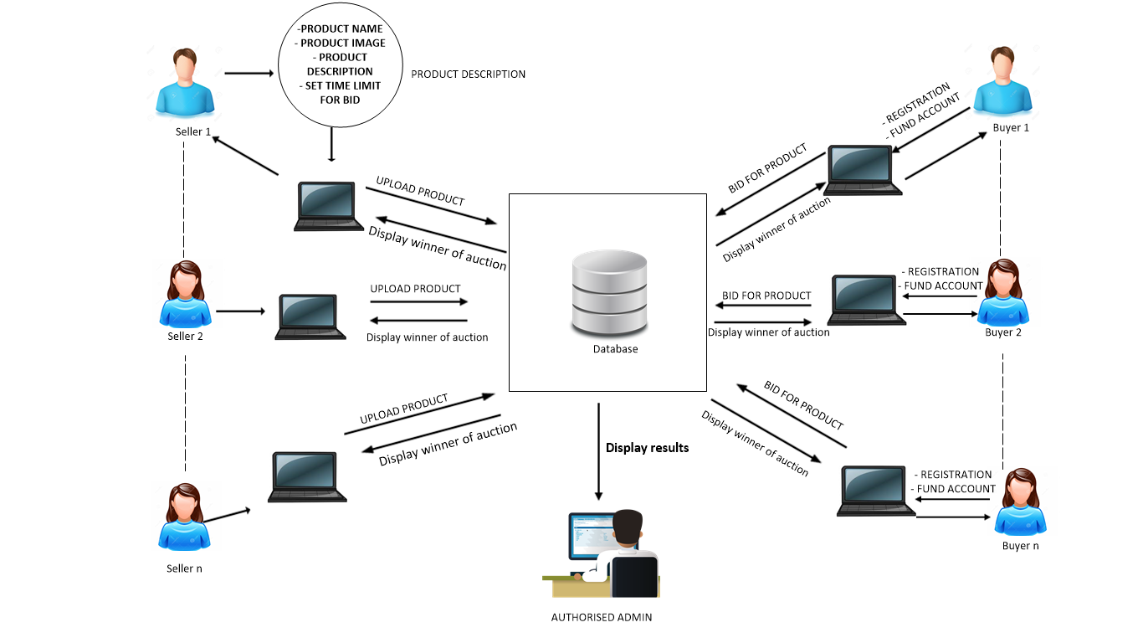

Figure 3.1

Showing the architectural diagram for the system

**3.4 MODELLING THE PROPOSED SYSTEM**

The project will be developed using Top down approach thus, the following presentation models will be used

1. Flow Chart
2. Use case diagram

**3.4.1 Flow** **Chart**

The flow chart gives the description of the flow of process from the start of the application to the end of the program**.**it is a diagram that represents an algorithm work flow, or process. Flowchart use simple geometric symbols and arrows to define relationships.

**Figure 3.2**

Showing the Flow Chart for the System

**3.4.2 Program Use Case Diagram**

A use case is a list of actions or events steps defining the interaction between a role (known as actor, and a system to achieve a goal. They can be documented with text or linked to UML model that develop the scenario in a more detailed form. The actors can be human, an external system or time.

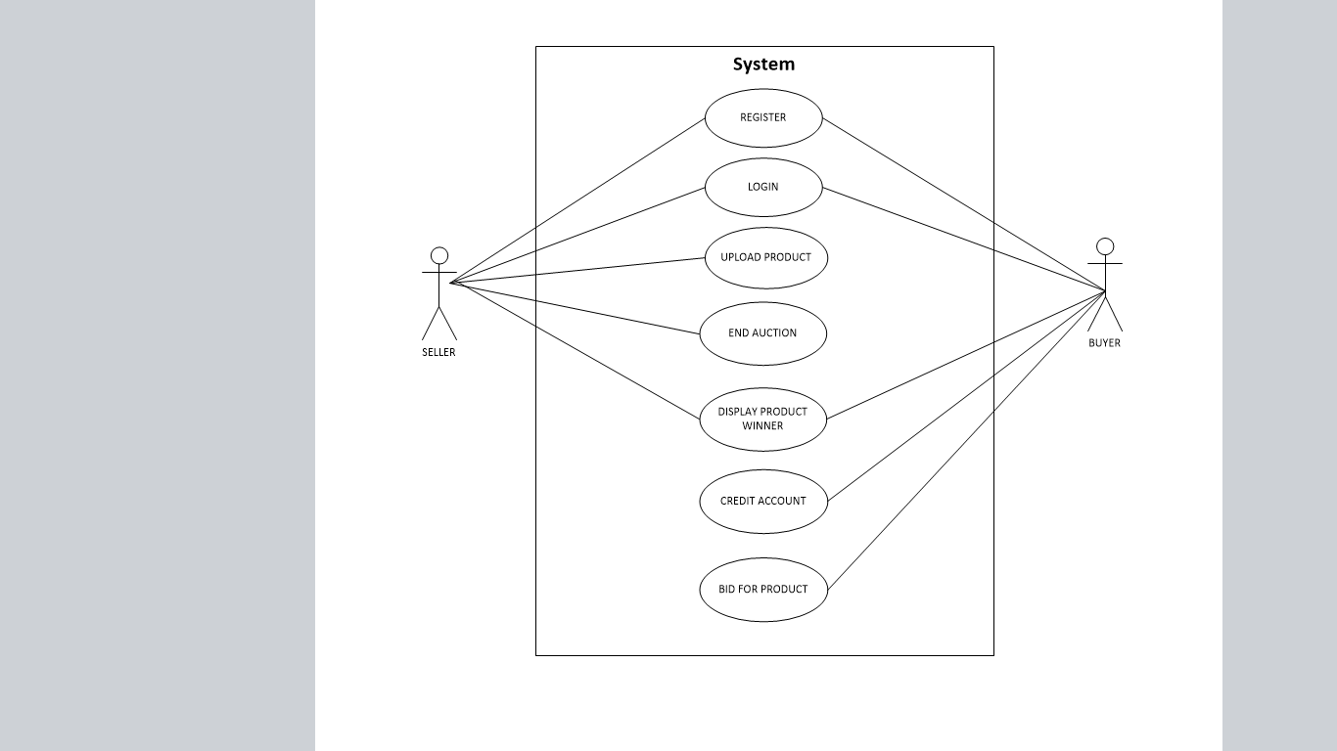**Figure 3.3** **Showing use case diagram of the syste**

**3.5 METHOLOGY TO BE USED IN THE PROPOSED SYSTEM**

**3.5.1 Overview of Software Methodologies**

A software development methodology or system development methodology in software engineering is a framework that is used to structure, plan and control the process of developing an information system. A software framework is a universal reusable software platform used to develop applications and solutions .The development of basic projects can be divided into different stages which are project planning, requirements definition, design, development, integration and testing, installation and acceptance.

**3.5.2 Software development phases**

The process of developing software generally involves a set of different phases. These phases involve planning and design, implementation, testing, documentation, deployment and maintenance.

* **Planning and designing**

This is the first phase in the software development .The requirements and analyses are gathered from the buyers and the sellers in the auction system. Everything required for the development of the auction system is clarified from the different users of the system

* **Implementation**

This stage involves the translation of the system structure into an executable program. For the auction system PHP is the programming language that is used to translate the system structure. The other programming languages used include Java Script HTML MySQL and CSS .The use of these programming languages allows for the development of an online auction and biding system. The database management system that is to be used for this project is Mysql and WamppServer is the Integrated Development Environment (IDE).The program will be written in a certain programming language.

* **Testing**

This involves running the system and evaluating the defect that can arise and actions are carried out to correct the defects. The methods for testing the system involves unit testing which tests the different components of the system that is the system’s interfaces, data storage and how the different selling and buying activities are being carried out.

* **Documentation**

This phase involves taking note and recording all the activities during the development process. The documented information is relevant for upgrades or updates that may be required on the system and for future referencing when carrying out maintenance.

* **Deployment and Maintenance**

This involves the presenting of the final software product to Computer Science department. The product can then be customised to meet the user’s required needs and put into operation. The newly discovered faults can be cleared and missed requirements can be added.

**3.5.3 Build Methodology**

In this project the build research methodology is going to be used as the research methodology. After taking into consideration the different factors which include the time constraint, budget and the complexity of the system that is to be constructed the build methodology proves to be the most appropriate methodology to use in the development of this system. The build research methodology involves building an artifact either a physical artifact or a software system to demonstrate that it is possible, this accelerates the development of the auction system as the system is built as part of the research methodology. This methodology involves the construction of the artifact must be new or it must include new features that have not been demonstrated before in other artifacts and these new features involves the use of a matrix to determine the seller’s and the other feature is the use of the detailed feedback rating as opposed to the use positive, negative or neutral to provide the feedback.

Whenever a research question leads to the building of a software system, the researchers involved should consider the following set of good practices design the software system no matter how simple the system is. In choosing a programming language there are various factors that have to be considered which are reliability, expressiveness, run-time speed and available libraries. The build research methodology best suites this project because the working software is the end product and the project involves building an artifact that encompasses new software features which makes this methodology the most appropriate one.

**3.6 Software Development Models**

There are a number of software development models that that are in existence. In the development of this system we have to choose the best suitable approach for the given project to produce a quality end product.

**3.6.1 Rapid Application Development**

After considering the different types of software development methodologies the one emerged as the most appropriate method for this project was the rapid application development methodology. It is the appropriate methodology because it reduces the cost of production and the time dedicated to the development. After looking at the project timeline as well as the developer’s technical skills and the project budget Rapid Application Development proved to be the most appropriate software development methodology. Rapid Application Development makes use of computer aided design tools which will be used in the development of the project. RAD will be most appropriate for this project as RAD works best for projects whose scope is small and the work should be broken down into manageable chunks Taking into consideration the short timeframe of the project it would be appropriate to select a software development methodology that allows for the project to be developed over a short space of time.

 Figure 3.5.a illustrating the Rapid Application Development (Liang, 2003)

Rapid development, high quality and lower costs go hand in hand if an appropriate development (Reece, 2012). In RAD model the functional modules are developed in parallel as prototypes and are integrated to make the complete product for faster product delivery.

Since there is no detailed preplanning, it makes it easier to incorporate the changes within the development process. RAD projects follow iterative and incremental model and have small teams comprising of developers, domain experts, customer representatives and other IT resources working progressively on their component or prototype.

The most important aspect for this model to be successful is to make sure that the prototypes developed are reusable.

## 3.6.2 RAD Model Design

RAD model distributes the analysis, design, build, and test phases into a series of very short, iterative development cycles. Below are the phases of RAD.

**Business Modeling:** The business model for the product under development is designed in terms of flow of information and the distribution of information between various business channels. A complete business analysis is performed to find the vital information for business, how it can be obtained, how and when is the information processed and what are the factors driving successful flow of information.

**Data Modeling:** The information gathered in the Business Modeling phase is reviewed and analyzed to form sets of data objects vital for the business. The attributes of all data sets is identified and defined. The relation between these data objects are established and defined in detail in relevance to the business model.

**Process Modeling:** The data object sets defined in the Data Modeling phase is converted to establish the business information flow needed to achieve specific business objectives as per the business model. The process model for any changes or enhancements to the data object sets is defined in this phase. Process descriptions for adding, deleting, retrieving or modifying a data object are given.

**Application Generation:** The actual system is built and coding is done by using automation tools to convert process and data models into actual prototypes.

**Testing and Turnover:** The overall amount of testing time is reduced in RAD model as the prototypes are independently tested during every Iteration. However on the other hand the data flow and the interfaces between all the components need to be thoroughly tested with complete test coverage. It reduces the chances of major issues since most of the programming components have already been tested.

**3.7 Development Tools**

In the development of our online auction system we are going to make use of a number of development tools. The tools that are going to be used will ensure the deliveries of goods are reliable end product. The tools used are platform independent so that they can be used on different hardware and software systems. To ensure proper development of the auction system we used some of the following tools Unified Modelling Language (UML), HTML PHP, MYSQL, java script and WamppServer is the Integrated Development Environment (IDE).

**3.7.1 Unified Modelling Language**

The UML is an international industry standard graphical notation for describing software analysis and designs (Williams, 2004). UML is a unification and standardization of earlier modeling notations of Booch, Rumbaugh, Jacobson, Mellor and Wirf-Brock, among others. UML is an object oriented approach which allows for an easy way to translate it to object oriented code. The Unified Modeling Language (UML) is a language for specifying, visualizing, constructing, and documenting the artifacts of software systems, as well as for business modeling and other non-software systems (Mitchell, 2003). UML uses simple graphical notations that non-programmers can also understand its model. UML makes use of sequence diagrams, use case diagrams and state chart diagrams. UML diagrams are used to show system requirements and the general system design. UML is very important in the use of RAD as it facilitates the development of the project.

**3.7.2 PHP**

PHP (recursive acronym forPHP Hypertext Pre-processor) is a widely-used open source general-purpose scripting language that is especially suited for web development and can be embedded into HTML. Since this project will be based online it will be appropriate to develop this project using PHP. It is a server side scripting language that is used to develop dynamic web content and allows for the communication with the database. PHP can perform any task that any CGI program can do, but its strength lies in its compatibility with many types of databases and also PHP can talk across networks using [IMAP](http://www.webopedia.com/TERM/I/IMAP.html), [SNMP](http://www.webopedia.com/TERM/S/SNMP.html), [NNTP](http://www.webopedia.com/TERM/N/NNTP.html), POP3, or [HTTP](http://www.webopedia.com/TERM/H/HTTP.html).

**3.7.3 MYSQL**

MySQL is one of the world’s mostly used open source relational database management system (RDMS) that runs on a server providing multi user access to a number of databases. This makes it suitable for the development of the online auction system. MySQL is a popular choice for developing web applications due also to the fact that it is portable across different platforms.

**3.8 Computer Aided Software Engineering (CASE)**

For thesuccessful development of this online auction and bidding system, for the delivery of the required functionality and performance to the user, CASE tools are used. CASE tools are software systems which are intended to provide automated support for software process activities and are often used for method support. The CASE tools were used to ensure maintainable, depended-able and usable software (Somerville, 2004). The IDE that is going to be used for this project is WampServer. WampServer is an integrated Development Environment (IDE) which is a windows web development platform on windows that allows you create dynamic web applications with Apache2, PHP, and MySQL. The online auction and bidding system will be implemented using the following programming tools:

* HTML
* PHP
* CSS
* JavaScript.

**3.9 Conclusion**

This chapter focus on methods that will be used in the development of the application. The purpose is to determine how the system is intended to be built and how to obtain the information needed to derive the actual result of the system. It gives detailed information about the procedures, tools, technologies, CASE, models, architectures, analysis of existing system and the proposed system. Build methodology was chosen as the suitable research methodology. This chapter also provided justification for the choice of RAD as our software development methodology.

REFERENCE

*Fred Barwell,Richard Blair,..(2004)'Professional* [*VB.NET*](http://VB.NET) *2nd Edition',Wrox Press Ltd.*

[*www.auction.indiatimes.com*](http://www.auction.indiatimes.com)

[*www.ebay.com*](http://www.ebay.com)

[*www.msdn*](http://www.msdn)*. Com*

*Brien (2001). “Auction based electronic markets best represent the changes to business inherent in e-commerce.” [Accessed April 11th 2018]*

*Ghose (2006), “The online auction market provides the consumers with great advantages of low prices”. [Accessed April 11th 2018]*

**CHAPTER FOUR**

**SYSTEM DEVELOPMENT AND IMPLEMENTATION**

**4.0 INTRODUCTION**

This chapter is concerned with the results that were obtained from the implementation of the Online Auction and Bidding system

The implementation aspect refers to all the activities that was conducted to develop the application and its operation i.e. using the approach stated in the methodology used to achieve the objectives in the project (e.g. use-case diagrams, activity diagram, etc.) in order to convert the theoretical design into a working system. The objective of this system is

1. To allow registration of the various sellers and the buyers of products (bidders)
2. To enable sellers upload products for auction with appropriate description of products.
3. To enable seller set time limit for each product being auctioned.
4. To notify the buyers (bidders) of new bids made in the bids that they participate in.
5. To generate reports for each completed bid in the auction system
6. To compute the seller’s ratings using the feedback scores from the bid winners

The application which is called **DolphieBid** was developed using WampServer as IDE, HTML (Hypertext Markup, CSS, (cascading style sheet) Hypertext Preprocessor (PHP) and MySQL database. DolphieBid has a very simple user interface to enable every user easily understand the various aspect of the application and requires no expertise to work with them.

The web based application developed is a platform where sellers and bidders perform certain functions and relate. A seller uploads a product to be auctioned and buyers/bidders start bidding and at the end of the bidding session the product is sold to the highest bidder. Time frame is given for each product all products are up for auctioning for a particular period of time before the session finally ends as wand also an instant report of, last bidder, price and time.

**4.1 SYSTEM ANALYSIS AND EVOLUTION OF RESULT**

The Application which is called DolphiBid has been created to effectively establish a platform of easy marketing, selling and purchase of products with minimal stress

It consist of data such as name, e-mail, phone numbers, credit card details, passwords and username gotten from both sides which are used to register and sign in users. The sellers in this system have a signup hub and a login panel as well. A seller cannot be a bidder simultaneously and vice versa. Buyers/purchasers/bidders also have a signup panel and a login panel clearly designed in the interface to avoid any form of misunderstanding or confusion. All products that are uploaded by sellers are well described and labeled to enable bidders make their choice, and payment is done online. Products are bided for, paid for, and delivered with little or no human intervention

The seller and the purchaser who connect through their respective browsers are connected to the auction website the auction web server communicates with the Database. The developed system is interactive; it can be accessed simultaneously by sellers and bidders as long as both are connected to the internet

**4.2 ONLINE AUCTION AND BIDDING SYSTEM APPLICATION VERSUS EXISTING SYSTEM**

Most of the applications today such as **CrayBid** have problems surrounding their functionality which causes issues in the system, some of which may cause dissatisfaction for users.

Possibilities for deceit in many cases items for auction are unique given the fact that buyers cannot see them, they can receive a defective product, buyers can also make deceit, the degree of risk is therefore very high. There is also a case of Limited Participation whereby some auctions are by invitation only while others are open to concessionaries there is the issue of Security in the existing system thus some customer to customer (C2C) auctions realized on the internet are not secured and some customers are afraid of deficiency of security. Software is also an issue in the existing system as only a few software solutions can support the dynamic trade in times of price optimization strategies.

The proposed system is such that the manual process of applying and bidding for products will be transformed to be performed online then after the product has been bided the details of the product and the cost will be captured and saved to the database for future retrieval. Below are highlights of how application is designed or works:

|  |  |  |  |
| --- | --- | --- | --- |
| S/N | Functions | Existing Systems | DolphieBid Application |
| 1 | Limited Participation | Yes | No |
| 2 | Manual input from users | Yes | No |
| 3 | Instant record generation | Yes | Yes |
| 4 | Last bid details, last bidder, price and time | No | Yes |

Table 4.1 Proposed Systems versus Existing System

**4.3 SYSTEM PERFORMANCE**

The DolphieBid application was created with a simple user interface for users to easily maneuver their way around the application. The application is always up and active regardless of number of bidders online or on the site at the particular time. It display the increase in initial price on every product that is being bided on in the application and deduction from wallet

**4.3.1 The Sign Up activity**

This interface is responsible for the registration of new users. Some information about users are collected such as name, username, gender, phone number, email address, etc. Every user has to register in order to have access into the full functionalities of the application. No two users can register with the same username as that is the primary key used to identify each user as shown in figure 4.2 below:

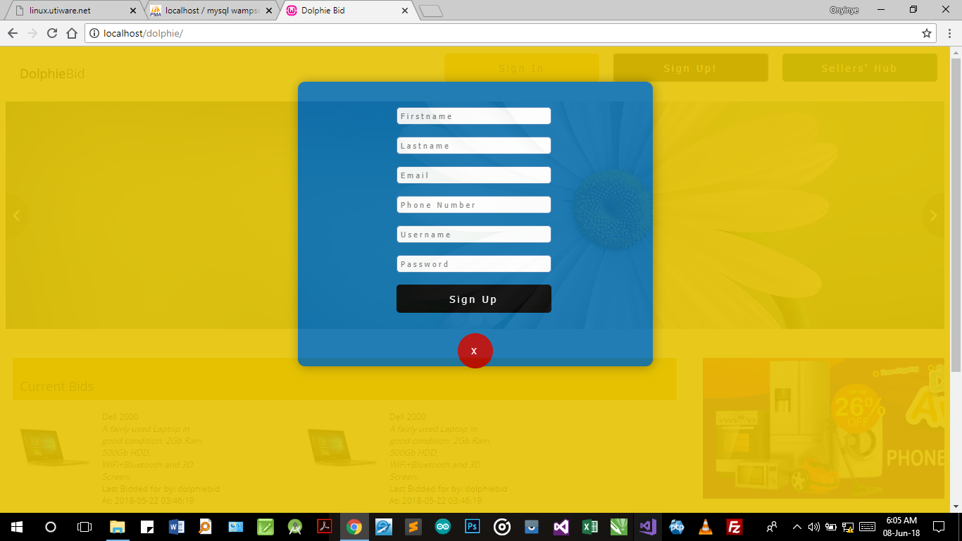

Figure 4.2 showing the sign up activity for new seller

**4.3.2 The Sign in Activity**

After registration, the user is expected to login to the home page with his/her username and password which was used to sign up for the account. The information that was provided during sign up is saved in a database which authenticates users at login. Figure 4.3 shows the login page.

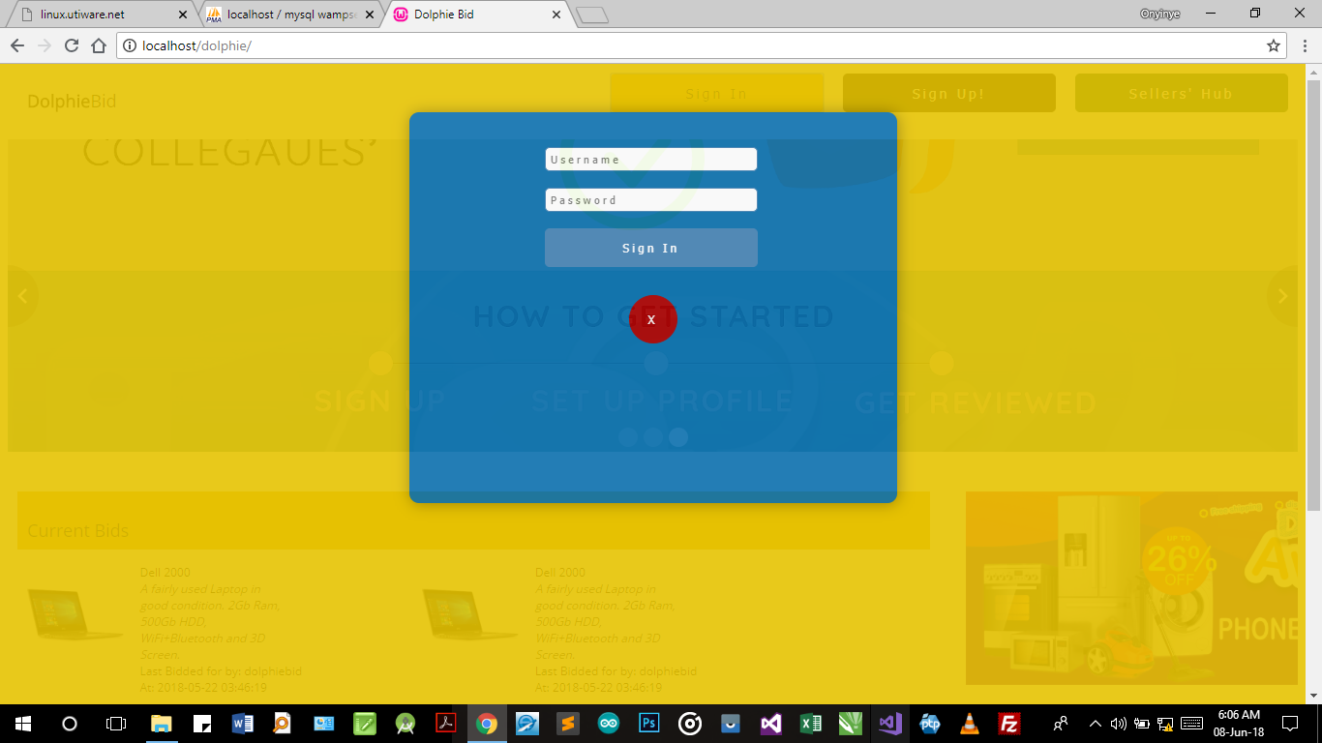

Figure 4.3 showing sign in activity

**4.3.3 Home Activity**

This is the heart of the application. This is the interphase where the products available for bidding are displayed for users to see and also this is where notifications of other products that will be available in the next auction are displayed. The home activity also contain the time limit available for every product indicated for every product, and also the increase made on products initial price and deducted from wallet .

fig 4.4 shows home activity:

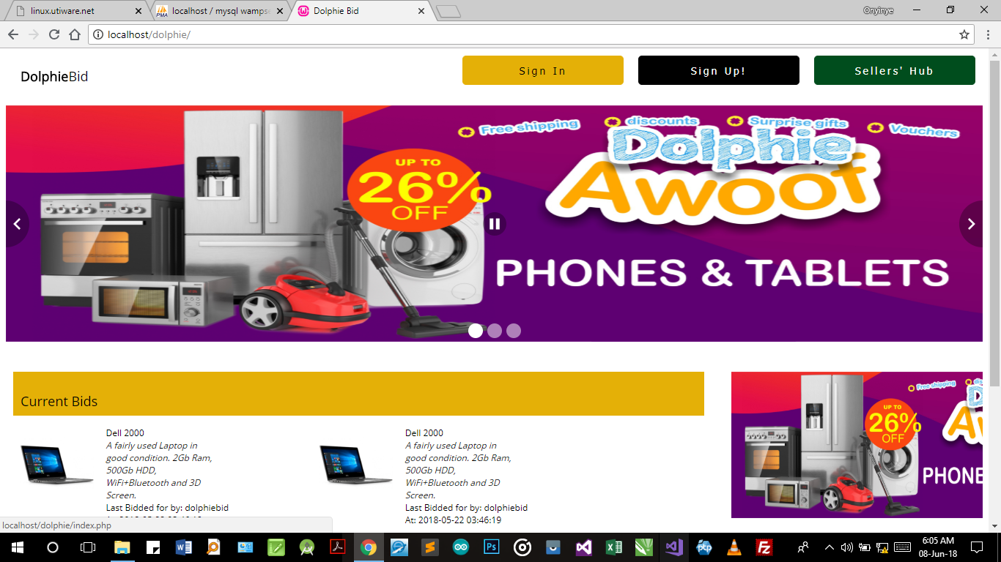

Figure 4.4 showing home activity

**4.3.4 Seller’s Hub**

This is the part of the application that allows new sellers register in the system and have their details saved in the database to enable them add products for auctioning on the web site

Fig 4.5 shows display of seller’s hub

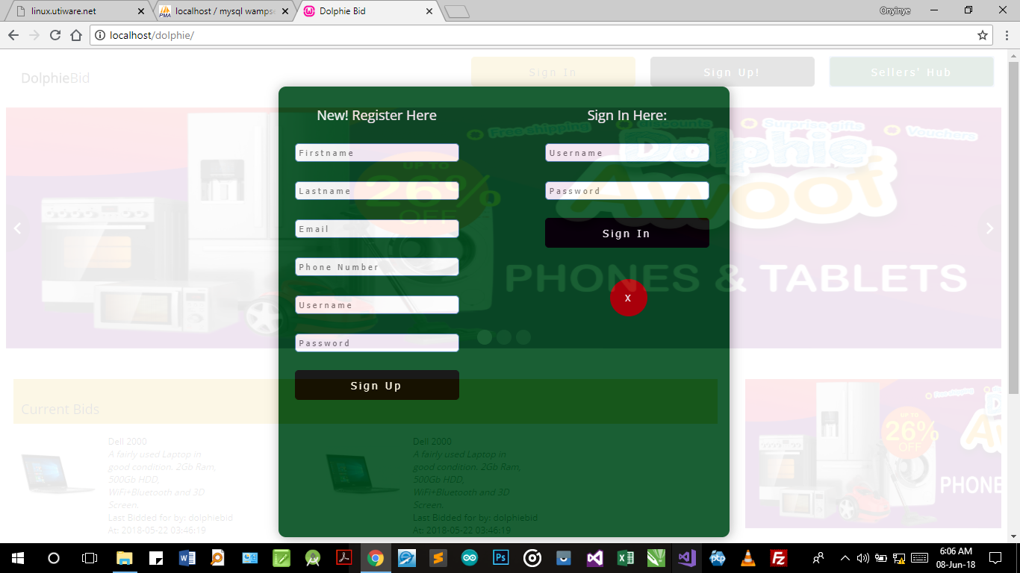

Figure 4.5 showing seller’s hub

**4.3.5 Seller’s Panel**

This is the part of the application that comes after the sellers hub, when a seller is done with registration and he/she signs in this seller’s panel enables the seller to add a product to be auctioned. It allows seller give details of product and the time limit wanted on the product

Fig 4.6 displays the seller’s pane:

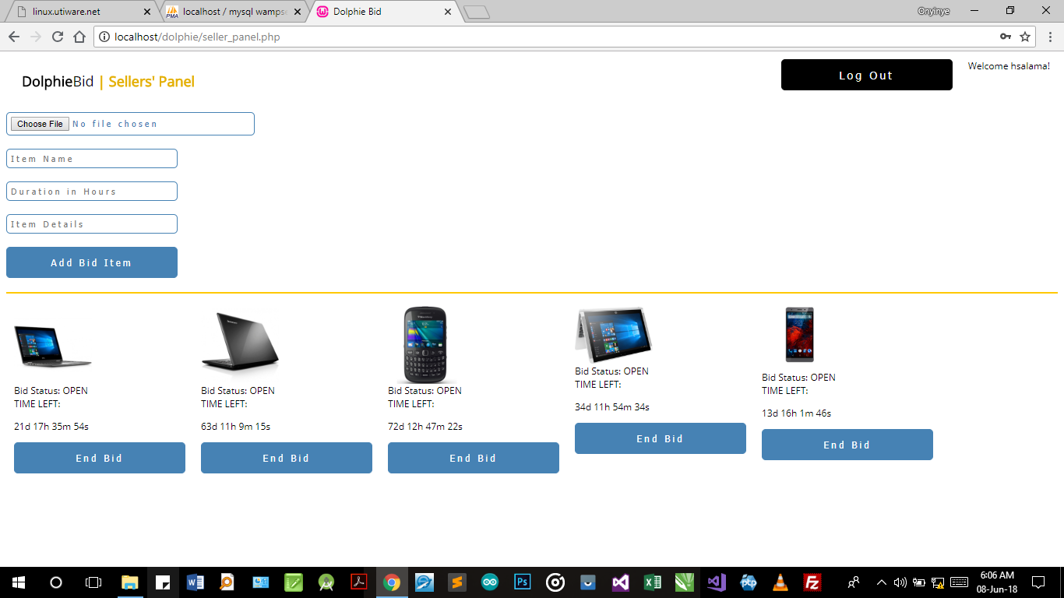

Fig 4.6 Showing seller’s panel for adding products for auction

**4.4 DATABASE STRUCTURE AND VIEW**

The database of the application contains details of both buyers and sellers as shown in figure 4.7

* The user registration table: This stores the information about users at the point of registration. The following are the details given by the buyers at that point of registration

1. First name
2. Last name
3. Password
4. Email

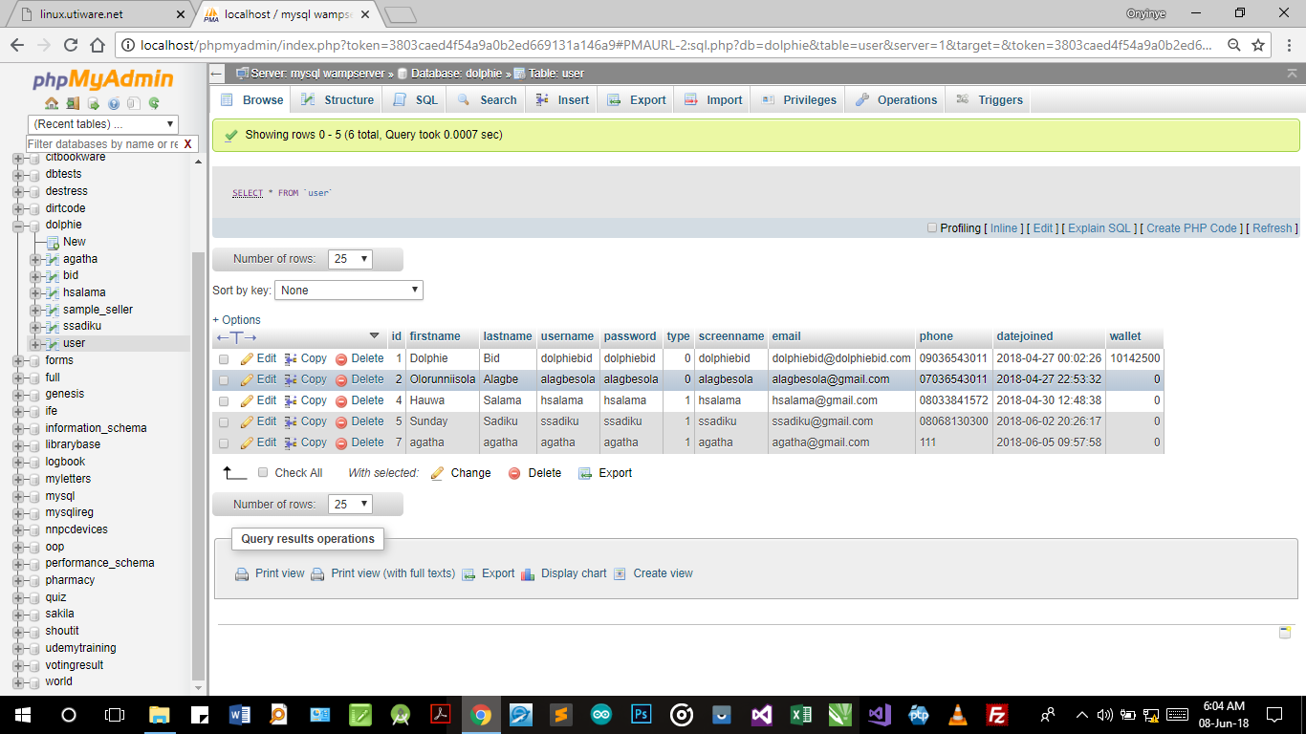

Fig 4.7 showing registration table of both sellers and buyers

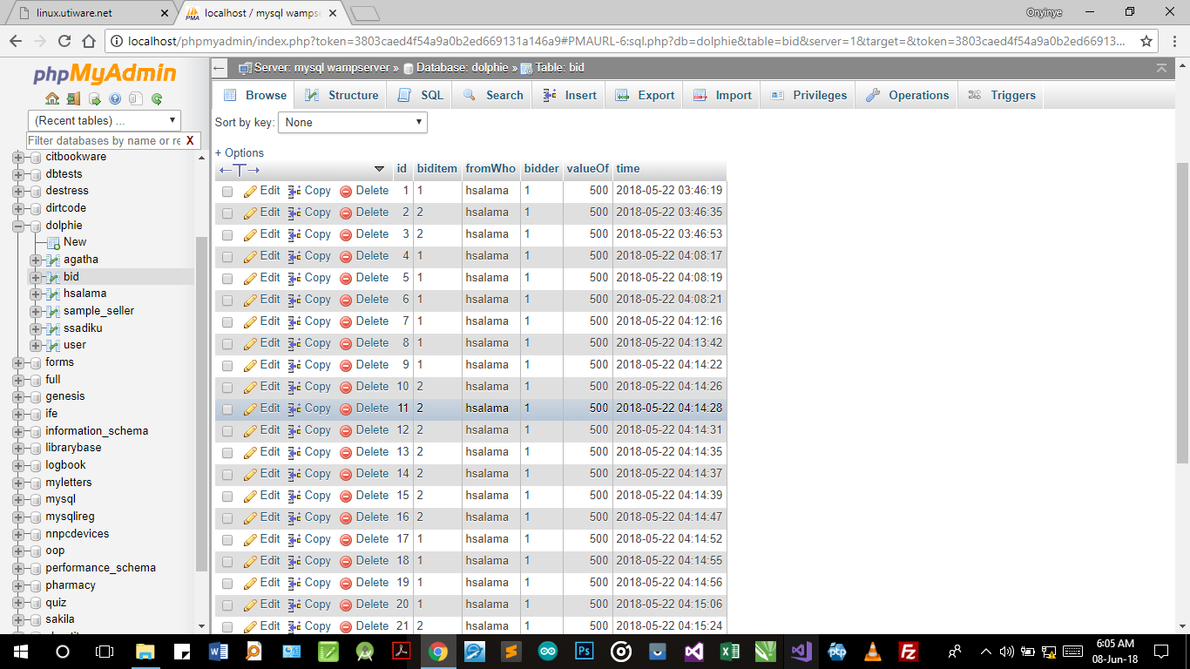

Fig 4.8 showing the bidding log for a product

**CHAPTER FIVE**

**5.0 SUMMARY, LIMITATIONS, CONCLUSION AND RECOMMENDATIONS**

**5.1 Summary**

Auction systems are a major component of the electronic marketplace that allows users at any site to sell and buy products. The sellers set up auctions for their different products while the purchaser who bids the highest amount wins the right to purchase the product in an auction.

In general auction systems usually make use of different various agents, the commonly used kind of agents include Purchaser Agent, Seller Agent and Facilitator Agent. Whereas the Seller Agent provides the function of registering goods for an auction to the sellers. This design maximizes the probability that the product auctioned sells. The second agent is the Purchaser Agent that requires bidding to buy and it suggests a proper bidding price by analyzing the bidding history of the bidding competitor. The third agent is the Facilitator Agent that plays the role of an auctioneer and enables a bidder to look at the other person’s auction history while bidding for and buying a product.

**5.2 Limitations**

They are limitations realized at the end of the project some of which are:

1. DolphieBid is limited to Nigerian buyers and sellers.
2. Inclusion of real payment system such as interswitch, and quick teller for funding seller’s account would be expensive

**5.3 Conclusion**

In conclusion, this is an auction system that deals with auctioning of product and bidding. It is a site that inculcates the new web technology in its full design. When this is will be hosted, it will be of great advantage to the populace at large.

**5.4 Recommendations**

Having presented all that is required for the successful implementation of this project research work, the following are suggested, aimed at improving and eliminating the problems associated with the manual of Auctioning. The measures are as follow;

* This website should be hosted for the advantage of the populace.
* The server should be managed by a database administrator who has undergone training on using MYSQL database.
* The administrator should be a trusted person for the sake of the safety of biddings.
* There should be no hesitation in attending to the needs of the new system designed.
* Sms notification of new products should be communicated to buyers
* Seller’s rating to enhance reputations and trust from buyers

**REFERENCE**

*Adams, C, and Newberry, P.(2002), Vettes and Lemons on eBay [Accessed 22 march 2018] Allwright,A.& Oliver, R. (2004). Strategies for Optimizing BusinessRelationships, – A professional guide to contracting including model conditions, Aberdeen GroupBuying Goods and Services Revised by E SBest Practices in Contract Management –*

*Brien (2001). “auction based electronic markets best represent the changes to business inherent in e-commerce.”.*

*Corporate Social Responsibility (2005).CIPS European Community Supplies Directives - A guide for the Public Sector*

*Dimoka, A.(2008), Understanding and Mitigating Product Uncertainty in Online Auction Marketplaces [accessed 18 November 2014].*

*Dong (2007). “Every time a new bid item is registered, the auction time period is set, the auction closes the time-out expires”*

*Doyle, Robert A.; Baska, Steve (2002), "History of Auctions: From ancient Rome to today's high-tech auctions", Auctioneer, archived from the original on 2008-05-17, retrieved 2008-06-22.*

*Fraud, D. (2007).CIPS Law of Contract.CIPS knowledge paperF Harvey (Revised Edition 1998), , Paul Richards (FourthEdition 1999), Pearson EducationLegal and Procurement*

*Ghose (2006), “The online auction market provides the consumers with great advantages of low prices”.*

*Kenneth Lysons & MichaelGillingham (2003) How to series Understanding Organisations.PearsonEducationService Level Agreements, K Lysons,CIPS “, CharlesHandy (Fourth Edition 1993), PenguinRisk Management in Purchasing &Supply Management - Positions onPractice, CIPS*

*Moustafa,H.(2012), Investigating critical success factors for online C2C auction in Egypt. Available from http://Hussein.moustafa@guc.edu.eg[Accessed accessed 18 march 2018]*

*Practice, CIPS Contract Management. A range of practical guides and toolkits – Office ofGovernment Commerce*

*Processes – StudyGuide, Eoin Lonegan & Bernadette King(Revised edition 2003),*

*Simon,W.(2013), Managing Online Auctions: Current Business and Research Issues available from http://* [*pinker@simon.rochester.edu*](mailto:pinker@simon.rochester.edu) *[accessed 18 march 2018]*

*Singleton & K R Burnett (1997), CIPS Contract Management - Positions on*

*Weinberga D.(2006), Exploring the WOW in online-auction feedback[accessed 18 march 2018]*